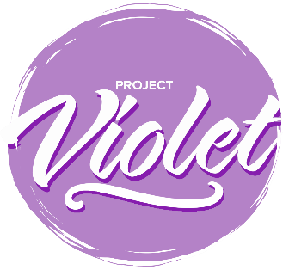

Project Violet – Commitment to Action

Colleges

Please send to projectviolet@baptist.org.uk by 30th September 2024.
The commitment to Action responses will be collated and form the basis of a report that will be submitted to the Baptist Union Council in October 2024.

Name of College
How have you discussed the findings?
For example, meetings and dates

These are listed in the priority order agreed at the Project Violet Co-researchers conference on 18 April 2024.

Request Number | Short Name | Accepted | Modified | Declined
R34 | Colleges develop a module in inter-cultural ministry and communication
R26 | Improve access to funds for ministerial training
R08 | What Colleges teach Ministers in Training
R43 | Moderation of the translocal space
R01 | Invitation to Colleges to review their Admissions processes
R05 | Training in advocacy on behalf of for Ministers and MiTs receiving unequal treatment
R44 | A theology of disability that enables local churches, colleges, and Associations to reflect upon their practice
R29 | Access to debt and budgeting advice for MiTs
R45 | Ministry to the Deaf Community is Pioneer Ministry
R41 | Role Models
R35 | Review of the way in which NAMS are inducted into the habit of connection
R32 | Ongoing use of ‘I am because you are’ resource
R28 | Monitoring data throughout the vocational pathway
R02 | Create ‘Planning to train as a Baptist Minister Resource’
R56 | Use resources that reflect the diversity of Baptist life

You are invited to offer a narrative, if you would like to, on the decisions you have taken.

