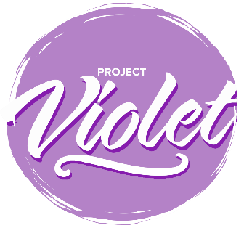

Project Violet – Commitment to Action

Please send to projectviolet@baptist.org.uk by 30th September 2024.
The Commitment to Action responses will be collated and form the basis of a report that will be submitted to the Baptist Union Council in October 2024.

Name of Stakeholder

How have you discussed the findings?
(for example, meetings and dates)

Using the ‘Listed by Stakeholder’ index, identify the Requests for Change that you are being asked to respond to and put their numbers in this grid. You can then download the appropriate Requests for Change from the website and discuss your responses.
Request Number | Short Name | Accepted | Modified | Declined

You are invited to offer a narrative, if you would like to, on the decisions you have taken.

