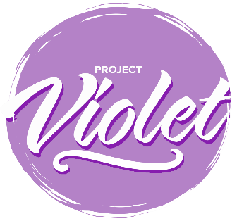

Project Violet – Commitment to Action

Local Churches

Please send to projectviolet@baptist.org.uk by 30th September 2024.
The commitment to Action responses will be collated and form the basis of a report that will be submitted to the Baptist Union Council in October 2024.

Name of Church
Association you belong to
How have you discussed the findings?
For example, meetings and dates

These are listed in the priority order agreed at the Project Violet Co-researchers conference on 18 April 2024.
Request Number | Short Name | Accepted | Modified | Declined
R53 | Make opportunities to listen to new voices
R51 | Local churches make their position on women’s ministry known prior to settlement
R41 | Role models
R48 | Developing slow wisdom in the local church meeting
R05 | Training in advocacy
R44 | A theology of disability that enables local churches to reflect upon their practice
R56 | Use resources that reflect the diversity of Baptist life

You are invited to offer a narrative, if you would like to, on the decisions you have taken.

