Guide to using Church Update
To access Church Update please use the link on our webpage www.baptist.org.uk/churchupdate

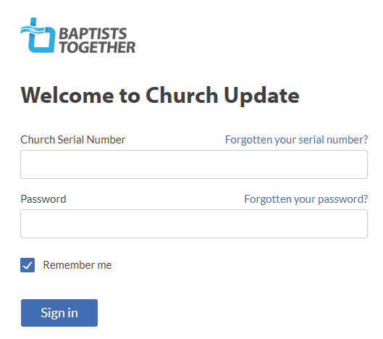
Enter your serial number and password and then click ‘Sign in’

Once you have logged in you can change your password – use the link on the left-hand side.

Logging in takes you to the Church Info section.
- If anything needs amending use the relevant ‘Edit’ button on the right, make the change and click Confirm (or Cancel to exit without making any changes)
- Please note that you are unable to edit the name of your church. If this is incorrect, please email our Database Administrator (churchupdate@baptist.org.uk)

Now move to the People section using the link on the left-hand side (if you are using a tablet or phone this may appear as a Menu icon on the top right next to your Church name).
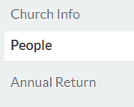
This is where you tell us about changes to people in key roles. The roles we need to know about are as follows:
Minister (including Lay Pastor and Minister-in-Training)
Church Secretary/Main Contact
Church Treasurer
Safeguarding Trustee
Designated Person for Safeguarding (DPS)
DBS Verifier
Children’s Worker, Families Worker, Youth Worker (paid roles only)

[For an explanation of what we mean by these roles please see page 4 of this document].
To view the information, we hold about each person click under their name.
- To edit their address, phone number or other contact details. Please use the relevant ‘Edit’ button on the right, make the change and click Confirm (or Cancel to exit without making any changes)
- To let us know that one of these people is not in the role listed Click ‘Edit Role’ and then ‘No longer in this role’. You will be asked to provide the date when the role ended. You are also asked if this person is taking on another role – click ‘Yes’ or ‘No’ as appropriate. If ‘Yes’ you will then be taken to the ‘Add Role’ option (see below)
- The contact details include the field ‘letter salutation’. This is the name you would like us to use as the normal way of addressing that person. (For example, someone whose name is ‘Jonathan’ might always be called ‘Jon’). Please do not leave this field blank.
- To let us know that one of the people listed has a new role, click ‘Edit Role’ and ‘Add New Role’. Choose the appropriate role from the Dropdown list and give their start-date
- When the main contact is being changed you need to add the new person BEFORE you can remove the former main contact/church secretary
- To go back to the main people page, click the arrow next to the person’s name
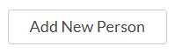
- To add someone who is not currently listed click ‘Add New Person’; fill in the relevant fields and make sure you add their role(s)
When finished click ‘Confirm’.
To cancel click ‘Cancel’ under ‘Add new person’ (top left)

Annual Returns
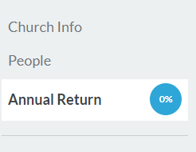
In “Annual Returns” season (normally December and January) you will have the option to complete your Annual Return. Access this from the menu on the left-had side. When this option is not showing, then the annual return window is closed, and a statement advising closure will be present at the bottom of the menu section.

On this page you will be told how much you have completed and how long you have before the system closes.
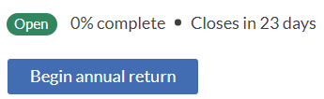
Also, on this page you are able to view the statistics we hold from previous years.
Click Begin annual return to get started!
If you have started and saved this, the box will say Continue Annual Return

There are two sections of figures – Statistics & Membership and Attendance – which you need to work through in this order. You should be able to view the previous year’ figures and there are pop-up boxes which explain what we are looking for.
Follow the instructions on the page but make sure you complete every box in both sections. If you need to enter a “0” that is accepted, but you may not leave a box empty, if you attempt this when you try to save the entry, it will return you to the top of the page.

Statistics & Membership
You should provide us with the relevant figures as at 31 December 2020. The figures we currently hold in our database for your church are shown in brackets. Please note that if you have not completed an Annual Return for some time these figures may be rather out-of-date.
Just click in each box and add the right figures. Please note that the fields in this section will only accept numbers.
IMPORTANT: Please do this even if the figures haven’t changed from those shown.
Number of children / number of young people /number of adults: Please give the number of children/young people/adults with whom the church has regular contact through church organised activities on Sundays and mid-week - e.g. Sunday school, uniformed organisations, youth clubs etc. Please note that the ages given are a guide and are not prescriptive.
Number of adults will be the largest number as it should include your members/Sunday service attendees and any outreach groups you have. It is primarily the outreach activity we are trying to gauge here, so it will be the year on year comparisons which are important (please be consistent).
Baptisms: This is the number of Believers Baptisms which took place in 2020.
If you are an ecumenical church (LEP) please put the total number of members in ‘Total LEP membership’ and the number of Baptist members in ‘Church Members’. If this box does not appear please ensure in Church Info , Church details, the LEP Church box says “Yes”. In some LEPs these figures will be the same as all members are seen as members of all the participating denominations.

Attendance
Please provide us with figures showing your current average attendance at your main weekly service of worship. Just click in each box and add the right figures. Please note that the fields in this section will only accept numbers, and will also require “0” rather than leaving blank. We ask for an age breakdown as follows:
Children (0-11), Young People (11-18), Young Adults (18-30), Other Adults (30-65), Seniors (65+)

We will leave you to decide how you work these figures out. For example, you could choose a ‘normal’ service and count all those who attend that day or you could work out the average over two or more weeks – or you may have your own method!
The third and final stage is the ‘Review’ process which gives you the opportunity to review (and edit if necessary) all the information we hold for your church.
At the bottom of the page is the Submit Annual Return button which you do need to click in order to submit the return to us.

Roles in Church Update

Church Secretary/Main Contact:
This should be the main (admin) contact person for your church (usually the Church Secretary) irrespective of their actual title.
You must have someone listed in this role in order to submit your return.

Church Treasurer
The key person to contact regarding church finances. Please ensure you list someone in this role even if it is ‘The Church Treasurer’ at the church address

Minister
Lay Pastor
Minister-in-Training
Non-Baptist Minister
This is the person/people who have been formally appointed as Ministers or lay-pastors of your church. If your Minister is from a different denomination (because you are an Ecumenical Church) please use ‘Non-Baptist Minister’

Safeguarding Trustee
The member of your Trustee Group (e.g. Diaconate) with overall responsibility for Safeguarding issues in your church.

DPS (Designated Person for Safeguarding)
The person (or people) who takes the lead on Safeguarding for the church.
DBS Verifiers See below – we display the information but it should not be updated here
Children’s Worker
Families Worker
Youth Worker
Please note that we only want to know about those people appointed to one or more of these roles in a PAID capacity. If someone is employed in a role which covers more than one of these (e.g. Children and Families Worker) please add them in both (or all three) of these roles.

Please note that people in your church who are in other roles (or are volunteer workers) are no less important – it’s just that we don’t currently need to know about them. Under Data Protection legislation we should only collect personal information we actually need.

To notify us of changes to DBS Verifiers please continue to use the online form at www.baptist.org.uk/dbsverifierchanges

