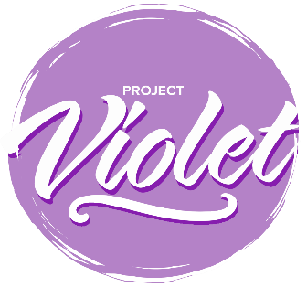

Project Violet – Commitment to Action

Associations

Please send to projectviolet@baptist.org.uk by 30th September 2024.
The commitment to Action responses will be collated and form the basis of a report that will be submitted to the Baptist Union Council in October 2024.

Name of Association

How have you discussed the findings?
For example, meetings and dates

These are listed in the priority order agreed at the Project Violet Co-researchers conference on 18 April 2024.

Request Number | Short Name | Accepted | Modified | Declined
R24 | Have a women’s Ministry advisor in each Association
R09 | Ensure Ministers’ groups are constructive and inclusive spaces
R40 | More opportunities for collaborative and flexible ministry
R55 | Improve accompaniment of women Ministers
R45 | Ministry to the Deaf Community is Pioneer Ministry
R43 | Moderation of the translocal space
R34 | Colleges develop a module in inter-cultural ministry and communication
R42 | Intentional support in women’s discernment
R04 | Intentional Leadership Development for Women Ministers
R06 | Regional ministers proactively discuss terms and conditions during settlement process
R17 | Access fund for translocal life and learning
R28 | Monitoring data throughout the vocational pathway
R41 | Role models
R56 | Use resources that reflect the diversity of Baptist life
R14 | Invitation to Regional Justice Hubs to undertake further research using the model developed in Project Violet
R05 | Training in advocacy on behalf of for Ministers and MiTs receiving unequal treatment
R23 | Resourcing Regional Justice Hubs
R38 | Occupational health service for ministers
R25 | Promote mutual learning between Urban Expression and Regional Ministers and local churches
R35 | Review of the way in which NAMS are inducted into the habit of connection

You are invited to offer a narrative, if you would like to, on the decisions you have taken.

