Using Art as a tool for theological reflection

By Rev. Laura Gilmour

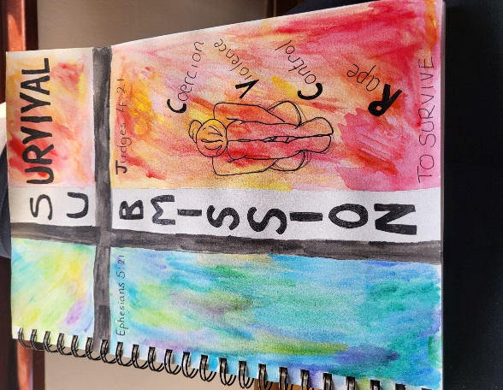The piece began as a picture I had painted as reflected on the subject, in this case the problematic use of submission language in churches for people who had experienced domestic abuse. The topic itself emerged as a wondering stemming from my personal discomfort about the issue. In the painted version the words pertaining to abuse were prominent and clear, almost like shouts or screams, though in the final piece I made these smaller, partly because they were a little too confronting of my own personal experiences. I did and remain hesitant to ‘shout’ about my experiences, the final piece then reflects this reticence also. So the in the final piece the words as smaller and along the outline of the cross, to draw the viewer in to observing the image more closely.

This was not intended to be a ‘pretty’ piece, it was meant to convey in a stark way the trauma, that to the survivor sometimes feels like it must be hidden, because it doesn’t neatly fit in to the lexicon and language of the church.

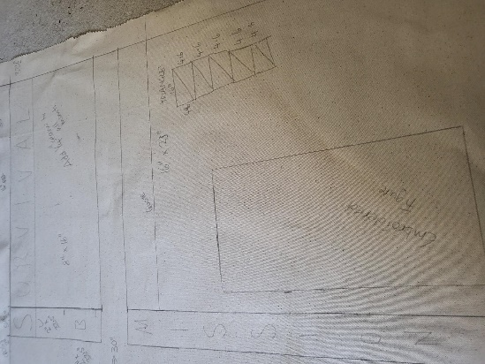I had initially thought that I might create the image using the medium of weaving, but later changed to the technique of quilting, which is a more conventional medium for church wall hangings. I felt that this fitted the theme of ‘tradition’ (in this case the medium and method of creating) versus the ‘message’ which was supposed to be jarring and certainly not one would expect of traditional church wall hangings which usually convey encouraging or comforting messages and verses from Scripture.

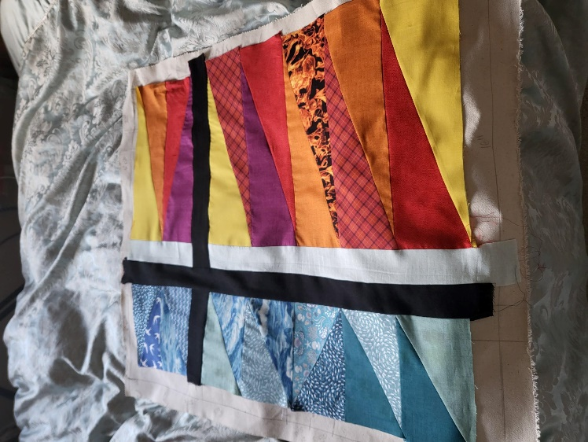

The black cross in the centre is the main structure of the piece, with the blue panels on the left side of the cross representing the ‘presenting self’ that being the ways in which people present to others in situations. The red / orange panel to the right side of the cross represents the ‘underlying self’, also to be understood as those thoughts, emotions and responses going on ‘underneath’ the presenting self.

The later addition of the words submission and survival anchor the piece in the topic of reflection. Both words sharing the common letter ‘s’ to highlight the intersectional nature of the two words in the life of a person who has experienced trauma through domestic violence, or at least that is the way that I had previously experienced the intersection of the two words.

Throughout the piece I have used fabric which was previously resident in my ‘stash’ left over from past projects, and this was intentionally so to represent the post traumatic remaking of the self. In post traumatic remaking trauma survivors often turn experiences into (hopefully) useful coping mechanisms in their remade self. In a similar way, these old offcuts of fabric are turned into something new, with a 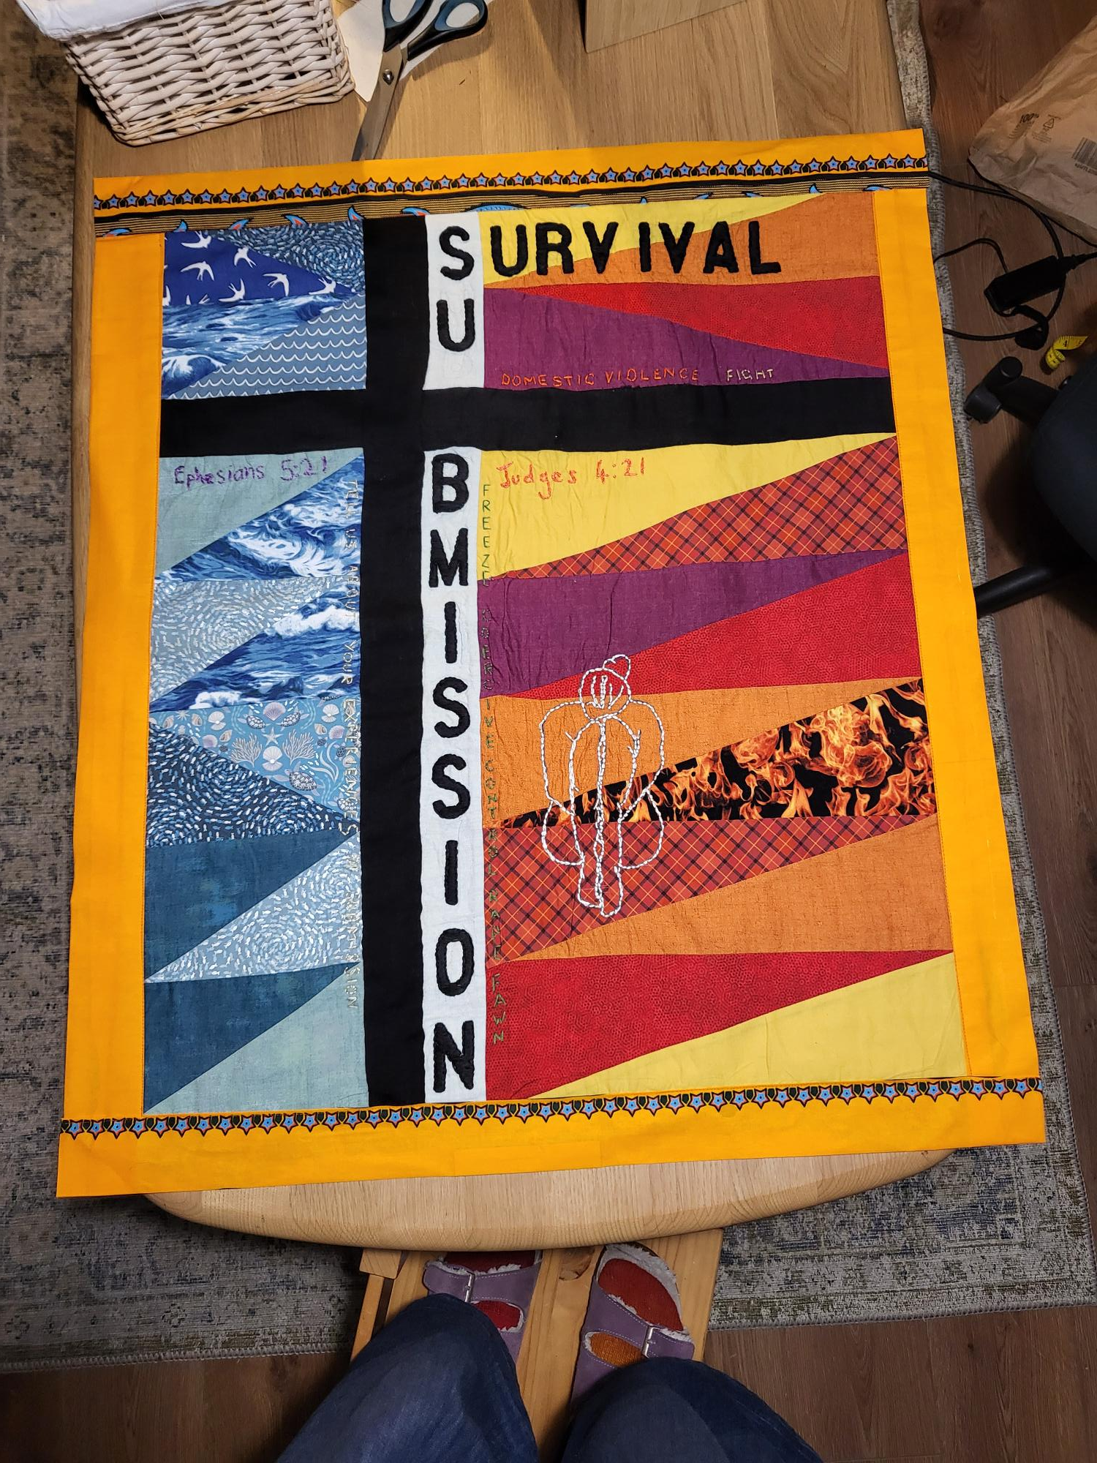message to deliver and which hopefully has its own kind of strange, confronting beauty.

The Details

As with traditional wall hangings there are two references to Scripture. Ephesians 5:21,[1] which is a commonly used reference in relation to submission and Judges 4:21,[2] deliberately provocative to represent a very ugly response. The Judges reference was chosen to represent feelings of anger, rage and female violence and the ways that, in submission and self-silencing these emotions, which are societally unacceptable when exhibited by women, are swallowed in favour of a more acceptable silenced version of the self. The language of these emotions are often silenced in pursuit of that which is a more culturally acceptable expression of female emotion.

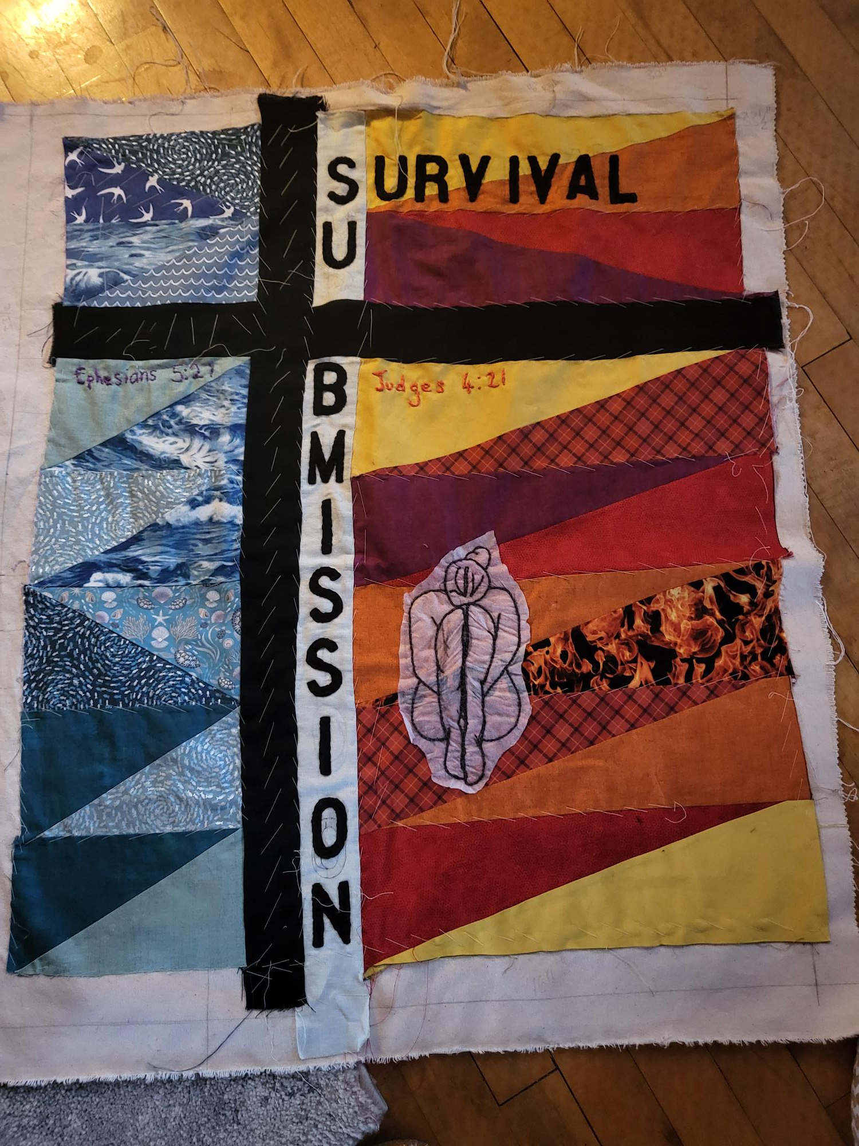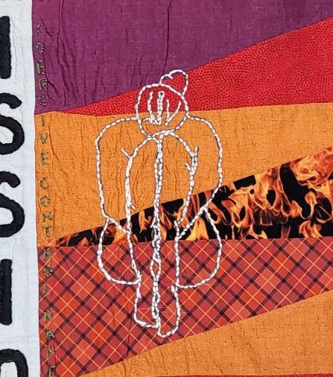The positioning of the female figure represents the posture of the victim, cowered, curled and protective, but also sorrowful.

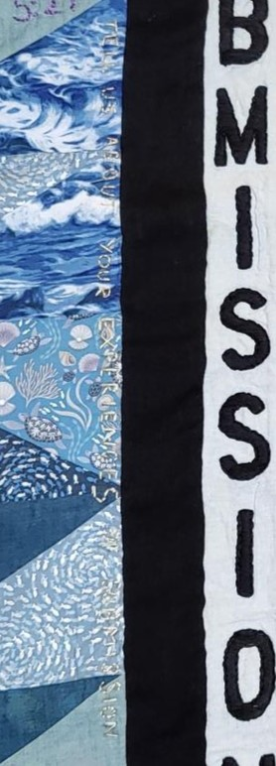The figure is double stitched, firstly in a dark thread and then overlain in a shimmering white thread. Again, this speaks to the post traumatic remaking of the self. The darker thread representing the shadow side of the self, the part that remains hidden from view most of the time, but present nonetheless, likewise with the experiences of trauma, integrated into the remade self, but not entirely gone away. The lighter thread represents the remade self, a re-emerging of the self after integration of the experiences. I hesitate to say ‘healing’ because this has connotations of the past forgotten, but a lighter version of the self regardless, one which is less constrained by traumatic experiences.

Finally, there is the triggering statement itself ‘Tell us about your experiences of submission.’ On the piece it is barely perceptible, and this was intentional. For those asking the question on the ministerial recognition form, it would likely have been barely perceptible too. Certainly, there would have been little to no understanding of how it might have been read by someone who had experienced abuse. It was probably a barely perceptible moment of their day when they read my answer to it. And so barely perceptible it is on the final cloth piece, with the ramifications, the ‘underneath’ of that question being demonstrated on the opposite side of the piece.

My use of textile art as part of the reflective process has become my preferred medium for theological reflection. The time that it takes to produce the piece induces an intentional slowing down of the reflection process which can often take months to complete. When each stitch has to be made by hand (or each weave on the loom) the slow stitching allows time for reflection on the issue at a deep level.

The use of the hands, very much an embodied process, allows for expression of ideas which are unconscious, or at least not cognitive thoughts. I often find that through the choice of colours, the selection of threads, even the mistakes that are made, there is a kind of non-verbal communication led by the body, through the hands. This is a language and way of knowing that is beyond that which relies solely on cognitive knowing and allows for expression of those things that are not yet cognitively apparent, even to the self as I reflect on the issue. This move from unconscious knowing to reflective cognitive knowing is aided by tis embodied method of theological reflection. In this way I often find that the reflection is at a much deeper level than if I had relied on cognitive reflection processes alone. It represents, what to me, is a more feminine expression and allows the ways that I may have silenced myself to come to the fore.

1. Ephesians 5: 21 – “Submit to one another out of reverence for Christ.”
2. Judges 4:21 – “But Jael, Heber’s wife, picked up a tent-peg and a hammer and went quietly to him while he lay fast asleep, exhausted. She drove the peg through his temple into the ground, and he died.”