Baptist Union of Great Britain

Safeguarding Training for Junior Leaders

Introduction to the training
Volunteering in the church, whether with the children’s groups or helping to wash up after coffee gives young people the opportunity to develop their confidence and communication skills. It can also be the first step for that young person to discover a passion, calling or vocation, setting them on a path to future ministry in one form or another.
This training has been developed by the National Safeguarding Team and members of the National Safeguarding Contacts Group (NSCG) for Baptists’ Together. It is intended to support churches to be excellent in safeguarding by making sure that young people who help with children’s work in the church are understand what they should do if they are concerned about something that they see or hear in the groups they are working with.
Who is it for?
This training is intended for young people aged 14 to 17 years old who would like to volunteer with children’s work in your church. It might be that they are planning to help with a holiday club, Messy Church or a Sunday School group.
Who should deliver the training?
The training is designed to be delivered by the Designated Person for Safeguarding for your church alongside the children’s group leader responsible for the group that they will be involved with.
How is the training delivered?
This training consists of a PowerPoint presentation (optional), discussion points and scenarios. If you are unable to share a PowerPoint presentation, or you do not think it is appropriate for your group then you can easily deliver the training using the leaders notes only to facilitate it.
It is helpful for those delivering the training to have read the church safeguarding policy and procedures before they begin. Although you will not be working through this with the young people you might find it helpful to reference.
Be aware of how the young people are engaging with the training and consider whether a short break might be appropriate as some point. This could be a comfort break or an opportunity for a drink and a biscuit.

How many young people can be trained at one time?
It may be that as a church you only have one or two young people seeking to volunteer at one time or you have a large group to train ready for a holiday club. This training can be adapted for any group of young people. We would encourage you to split groups larger than 10 into smaller sub-groups for the activities and discussion.
What is included in this pack?
The following material is included:
- Detailed training notes
- A PowerPoint presentation
- Game cards for the case scenarios (print before session)
- A Code of Conduct (Print one copy for each participant to sign
- An ID badge insert for junior leaders with behavioural expectations and what to do if they have a concern. (Print one for each participant)
What equipment do we need?
- Flipchart paper and pens
- Post it notes
- Ball suitable for indoors
- Laptop and projector (optional for showing PowerPoint)
Please remember that:
- Junior leaders should be included as children when you are considering how many adult leaders you need for a group or event.
- Junior leaders should never be left alone with a group of children.
- Not all young people will be suitable to work with children in the church. Just as you wouldn’t accept any adult to work with children and young people, the same consideration should be given to the individuals abilities and maturity, even if they are enthusiastic to help.
- Don’t forget that some young people may be upset by the idea that other children have been harmed. It is important to look out for signs of distress through the training and take time to talk this through with anyone upset individually after the session.

A final note about the training: Whenever we deliver safeguarding training to adults, we anticipate that there will be people in the room who have experienced abuse or continue to do so. As such, the training facilitators are aware of the importance of being aware of how people are responding during the training and allowing space at the end in case a participant wishes to share their experiences.
Just as adults on the training may have experienced abuse so may the young people on this training. It is really important therefore to be aware of how you junior leaders are responding to the material and follow up with any concerns after the training. You may like to explain to the group that the material may make them upset and explain what the young people should do if that is the case. Please also allow space for disclosures and follow your church safeguarding procedures in responding.

Outline Training Plan
This training programme is broken down into the following 3 sections:

Part 1 – What is safeguarding
- What do we mean by keeping people safe
- Who is responsible

Part 2 – Your role and behaviour
- What is your role?
- What are the expectations of a Junior Leader?
- Safer working practices?

Part 3 – Exploring Scenarios
- What do you recognise?
- How should you respond?
- Who should you tell?

Detailed Training Plan with Slide Numbers
Introduction to the course (5 mins):
Slide 1: Junior Leader Safeguarding Training
This is an opportunity to welcome the young people to the training session and explain that the training that they are undertaking today is to help them in their role as a junior leader.
Slide 2: Aims of this session
Read out of the aims as they are set out on the slide – this will make sure those who struggle to read the slide are also included.
Slide 3: Group expectations
This slide will help you to remind the group about the importance of engaging in the training, being respectful of others and the importance of confidentiality. Remember to tell the young people that if they share anything during the training that makes you worried about their safety or that of others then you will need to follow the church safeguarding policy and procedures.

Part 1 – What is safeguarding:
Slide 4: Title Slide for Part 1
This slide is just to introduce the section. You can put it up whilst you are preparing for the next activity.
Slide 5: How do we keep people safe?
This slide accompanies the following activity:
Activity: How do we keep people safe? (8 mins)
Ask young people what words or phrases come to mind when you think about how we keep people safe? Record answers onto a flip chart. Use this to capture their existing level of knowledge and understanding before sharing the definition.
Key phrases may include:
- Stopping people hurting or being hurt, both physically and emotionally.
- Recognising harm
- Knowing who can help if people are worried
- Supervising activities
Following this activity, share the definition below:
Slide 6: Definition of Safeguarding (2 mins):
Read allowed the definition of safeguarding which is on the slide:
“Safeguarding means protecting people from abuse, harm or neglect and making sure they have the right to feel safe, respected, and able to thrive.”
Slide 7: Safeguarding Policy (5 mins)
Explain the following
Every church has a safeguarding policy which sets out guidelines on the following:
- Responding to concerns about harm
- Responding to disclosures/allegations of harm
- Supervision of activities and excellence in safeguarding practice
- Helping victims and survivors
- Appointing, supporting and training volunteers
Slide 8: Signs of Abuse. (6 mins)
Alongside this slide you should explain that there are lots of different ways that people can be harmed and that as young people they will be aware of some of them.
Activity: Ask the young people to think of one thing they might notice if a child they are working with is being harmed.
Some examples would be:
- Bruises
- More quiet than usual
- Tearful
- Reluctant to go home
- Rude language
- Changes in behaviour or appearance (might have new clothes, a new phone, or have torn or ill-fitting clothing
- Telling you that they have been harmed
Slide 9 outlines the examples above. This is to be revealed following your discussion

Slide 10: Who is responsible?
This slide is an introductory slide to the next activity
Activity: Who is responsible? (10 minutes)
For this activity you will need to share or create a flowchart of how safeguarding responsibility works in your group or setting. (An example flowchart is included on Slide 10 and below in this pack.
Preparation: In advance of the training, identify the staff or volunteers within your church or children/youth programme and write individual names on pieces of card or large post-it notes.
For the activity, use pre-prepared names and titles relevant to your church this may include some of the following: Junior Leader, Group leader, DPS, Children’s Worker, Activity Leader, Safeguarding Trustee. Starting with the child at the centre of a concern, create a flow chart of how a concern should be progressed. Use coloured markers to join arrows between the cards / post it and put them in order on the wall or table.
Remember that if the concern is about the main group leader or the DPS the concern should be taken to another leader. This can be reflected by changing the flowchart. Talk through what to do if your concern is about a leader and their behaviour not just a concern about a child.

Slide 11: Flowchart example:
This slide has a very simple outline of how concerns might be reported. This is the starting point for your activity which will use the names and roles specifically of people within your setting. Note: You might want to explain to the group that not all concerns need to be passed to the statutory services
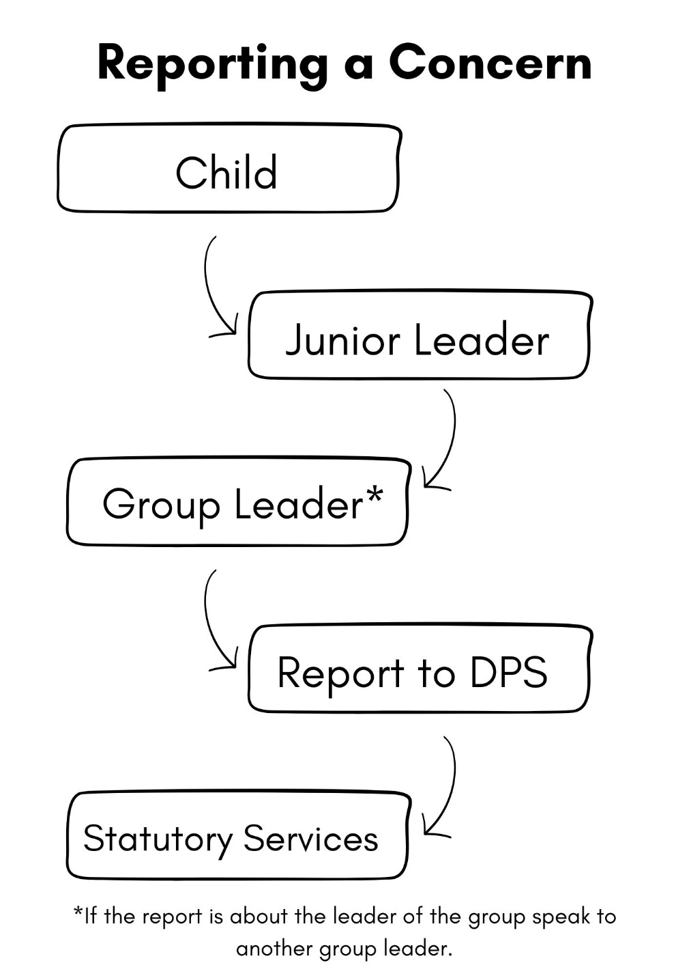

Part 2 – Your role and behaviour (2 mins):
Slide 12: Your role and behaviour
This is an introductory slide. Use the following statement to remind the group of their responsibilities as a junior leader:
“As a Junior Leader, you are in a position of trust and responsibility, and this has implications for your behaviour and the example you set. You should be given a clear idea of what you are being asked to do in your role and have the right level of support and supervision from the adult leaders. You will have to think about what to do to work safely.”
Slide 13: What is your role (2 mins)?
This activity is a discussion on job description for group or role and ensures that the Junior Leader is clear about what they are expected to do as part of their role.
Preparation: Prior to the training, make a list of activities that your junior leaders may be asked to undertake. Examples might include playing a supporting role in preparation of activities, helping with setting up, clearing away, helping children with craft activities, supporting children with craft/sport, making children feel welcome, ensuring everyone feels included, being a role model.
Activity: Helper not leader (10 mins)
This activity is designed to define the boundaries between the role of the Junior Leader and the role of the adults in charge.
Prior to training, make up your own list of activities that your junior leader may be asked to undertake and then get them to sort into columns using a flipchart or whiteboard – see example below.
Junior Leader | Adult Leader
Taking part in a game | First Aid
Helping with craft activity | Dealing with poor behaviour
Making sure child feels included | Supporting a distraught child
Tidying up after an activity | Speaking to parents

Safeguarding: This is also an opportunity to introduce the idea that safeguarding is everyone’s responsibility and that this means that if they are concerned about someone or see something that worried them, they should tell a leader or the DPS.
Slide 14: What are the expectations of a Junior Leader?
Activity: Encourage the Junior Leaders to think about the skills and gifts of a Junior Leader and to list them using either post-it notes or the ball activity below. (10 minutes)
Distribute post-it notes and get the Junior Leader/s to write down as many ideas as possible. Depending on the number of Junior Leaders in the training, you could write individual lists then create a combined list.
Alternatively, you can sit in a circle and throw a ball between trainer/Junior Leaders taking it in turns to suggest ideas.
Examples of skills and gifts you might encourage:
Role model, language, kind, respectful, polite, dependable, creative, sensible, spirituality, responsible, reliable, team-player, willing to learn, adaptable, good communication skills, self-aware, motivated, attendance, active participation, sociable, approachable, conflict-resolution.
Slide 15: Code of Conduct (10 mins)
Alongside this slide you can explain to the group about the importance of the junior leaders having clear boundaries in how they work with the children in their group. You might like to give out the Code of Conduct at this point and work through the points below with examples of what issues might arise.
- Use of social media
- Photographs
- Personal care of a child in the group
- Appropriate physical contact
- Visible
- Know your limits
It is also important to remind the group that they should be under the supervision of an adult at all times and the safeguarding procedures sets out the number of adults needed to cover each group, including that although they are there to help Junior leaders are still counted as an extra person under 18 for the purposes of the procedure. It is therefore important that as a junior leader they listen to the adults in the group and follow their instructions.
Action: Provide Junior Leaders with the Code of Behaviour document and discuss the key points. The document can be signed at this point.

Part 3 – Exploring Scenarios:

Allow 20 minutes to do this activity
Slide 16: Exploring some scenarios
This is an introductory slide. You can explain that you will be working through some scenarios and the group will need to identify potential concerns. This may be about something that a child or young person tells you, something you see or hear that makes you worried about a child or even about the way other adults and leaders are behaving.
Slide 17: Exploring some scenarios (2)
This slide will help you to introduce the key questions for the young people to answer when thinking about the scenarios. Here are some examples of the general themes for the discussions.
What do you recognise?
- Types and examples of abuse
- Behaviour of children and young people
- Behaviour of leaders
- Disclosures
How should you respond?
- If you are worried about something you have seen or heard, tell an adult
- Listen to what is being said and take it seriously.
- Remain as calm as you can
- Confidentiality – pass on the concern but do not discuss elsewhere
- If you need additional help after a safeguarding concern or incident - ask for help from the DPS
Who should you tell?
- Adult leader of the group
- DPS

Slides 18-27: Scenarios- how would you respond?
Activity: This activity is designed to get the young people to say what they recognise and how they would respond in each scenario to reinforce the learning they’ve undertaken so far in the training. We’ve given 20 minutes for this activity, but this could take less time depending on the numbers in the group.
Preparation: Print out the scenario cards from the Resources for Printing folder. Printing double sided will result in the correct answer being on the back of the correct card.
Instructions:
This activity is styled as a game with cards listing the scenario on one side and the answer on the reverse like the example below:
Front Back
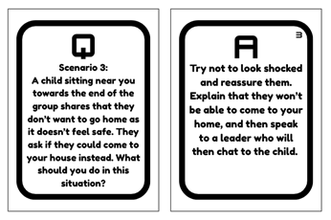
Each person playing the game takes a turn being the question master. You could do this by going clockwise around the group.
When it is each person’s turn, the question master picks up a card and reads the question on the card twice and then gives the rest of the group time to discuss the question before offering an answer. Your role as the person leading this training is to prompt the young people and help them think about the scenario and imagine it taking place in their context. Good prompting questions might be: What is happening in this situation? What do you notice? How do you keep yourself safe in this situation? How do you keep the young person/people involved safe?
Try not to jump into offering an answer but encourage and prompt the group to find an answer that connects to the learning that has already taken place. Listen out for young people who may be suggesting actions that go against the training, as well as those who don’t have much to say. The aim is that the group works together to answer the question, and each voice in the group is needed (this point might have to be reiterated). It might be helpful to have paper or a whiteboard available so that the young people can write down their thoughts and suggestions for answers. This helps those who are quieter to express their opinions.
The question master can read the answer when the group has had time to discuss it. The question master can award the group points on how well their answer lined up with the card (You could have sweets as part of a points system).
There are 10 scenarios. We recommend that the group discuss at least three scenarios or that each person in the group gets a chance to ask a question.

On the next page is a crib sheet to help leaders facilitate this activity.

Scenario Crib Sheet – Prompts for Leaders:
The cards for this game show the scenario and the answer to the question “How would you respond?” However, in facilitating this game you might also want to help the young people to think about what they recognise as going on the concern in the first place. Here are some prompts for each scenario.
Scenario | What do you recognise? | How would you respond?
- You're in the middle of a kids' club group when you see a child running out of the room through a side door. | The child could be in danger if they run out of the building, especially if there is a road nearby.  The child might go into parts of the building that it isn’t safe for them to be in. | Alert an adult leader immediately and make sure that you keep sight of the child until a leader is present. Don’t chase the child or shout at them, as this could lead to them running further away.
- A child in the group you're helping with asks you if they can tell you a secret. The child gestures that you should follow them to a quieter side of the room. | The child has something on their mind that they don’t want everyone else to know.  The child wants to talk to you on your own. | Politely explain to them that you can’t promise to keep a secret. Explain that they could have to share what was said with a leader. Don’t offer to go anywhere with them alone or share a secret of your own.
- A child sitting near you towards the end of the group shares that they don’t want to go home as it doesn’t feel safe. They ask if they could come to your house instead. | The child is worried about going home and they might be in danger at home. | Try not to look shocked and reassure them. Explain that they won’t be able to come to your home and then speak to a leader who will then chat to the child.
- Two children in the after-school club have started fighting. They are two children well known to you. | The two children involved could get hurt. Other children could get hurt if they get caught up in the fight.  Something has happened to cause a disagreement between the children. | Let a leader know straight away what is going on. Encourage other children to step back and keep away from the fight. Don’t shout at the children or try to pull them apart. You could get hurt or drawn into the fight.
- One of the children (Paul) in the club slips and bangs his head on the side of a table. Paul is upset and walks towards you, asking for help. | Paul is upset and he might have hurt himself. Paul might need some medical attention. | Console Paul and tell him to sit down. Fetch a leader who can offer first aid. Don’t just tell him to carry on playing, and don’t try to offer first aid yourself (you’re not trained or qualified to do so).
- Tiegan is waving a pair of scissors around during a craft session at messy church. | Tiegan might hurt herself or someone else by accident. It is dangerous to wave scissors around. | Politely ask Tiegen to put down the scissors and explain why her behaviour isn’t very safe. Ask if she can give you the scissors. If she refuses, let a leader know, and they can then respond. Don’t shout at Teigan or try to snatch the scissors off her.
- Lucas, one of the children in your group, is upset because of what another child has said to them. They are crying and very emotional. | Lucas has been upset by another child. Lucas is very emotional. Lucas might be being picked on by other children. | Try talking softly and kindly to Lucas. Seek to get his attention and see if he will explain what happened. Get a leader if you think they need more support. Don’t sit them on your knee or promise anything to get them to calm down.
- Sam needs to go to the toilet and asks you to take him. Sam is 8. | Sam wants you to go with him to the toilet. | You show him where the toilets are but do not go in with him. If he needs further help, then get a leader (2 required) to support him and return to the main body of the club.
- Hannah, aged 10, asks for a selfie and wants to message you. | Hannah is only 10 years old. Hannah wants to keep in contact with you. Hannah wants to be your friend but that isn’t appropriate. | Gently explain that that isn’t possible. See if Hannah wants to do another activity in the session.
- Tendai, a young boy in the group, is a little upset and asks you for a cuddle. | Tendai is a bit upset and wants to be reassured. | Firstly, touch should always be initiated by the young person and should be about their needs, not your own. Ideally, offer a space where he can sit next to you. Talk to him and see if you can reassure him.

