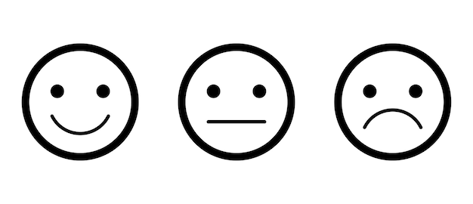
HAPPY | WORRIED | SAD

