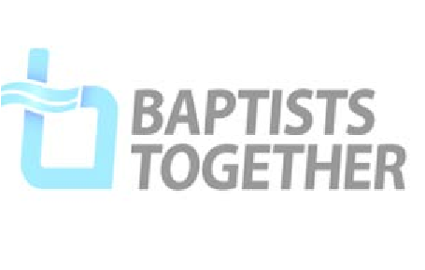


Easy Read

These are other types of abuse

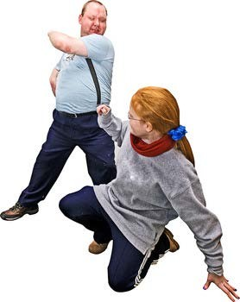
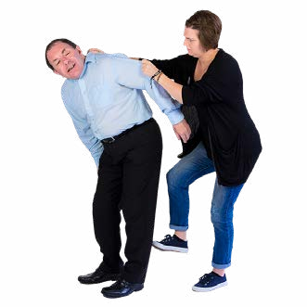
Domestic abuse
Domestic
abuse
is:
•
When a person threatens or harms someone in
their own family.
•
When a person harms someone they are in a
relationship with.
It can be any type of
abuse
.

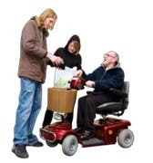
Mate crime
This is when a person pretends to be someone’s
friend so they can get something from them.
They might ask them for money.
You might hear someone talk about a friend who is
asking them to do things for them.

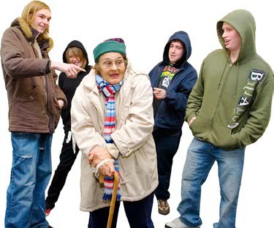
Hate crime
Hate crime is when someone is hurt or bullied
because of things like:
•
Their race.
•
Their religion.
•
Their sexuality.
•
Their disability.


Modern slavery
This is when someone is forced to work for very
little money, or for no money at all.
You might hear someone talking about this.

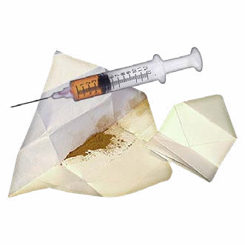
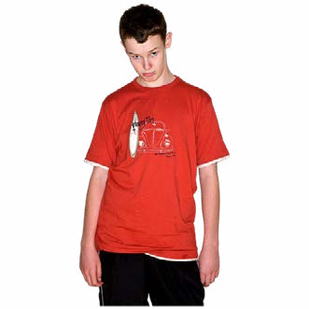

County Lines
County Lines is when illegal drugs are moved from
one place to another.
Sometimes gangs force children or vulnerable
people to do this.
It is against the law to sell illegal drugs. But
sometimes people get a lot of money by doing it.
Someone might suddenly have more money
or expensive clothes. They might look worried
when they get a message or call. They might
leave in a hurry.

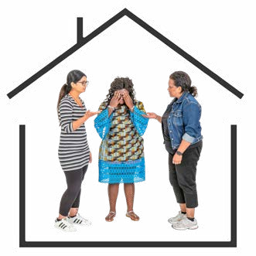
Cuckooing
Cuckooing is when a criminal takes over someone’s
home to sell drugs.
You might hear someone talk about having
someone in their house all the time. They might tell
you that they do not feel safe at home.

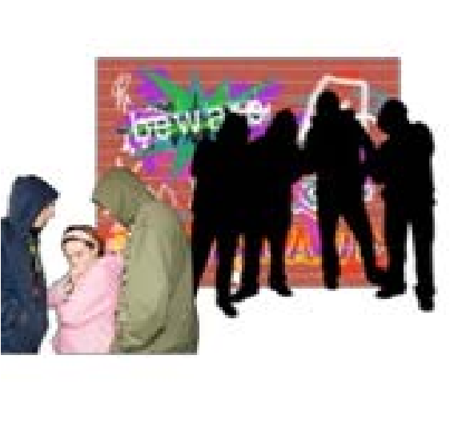
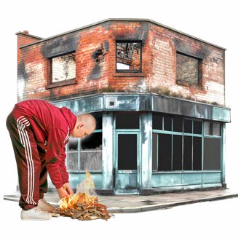
Radicalisation
Radicalisation is when a person starts to believe the
same things as bad and violent groups.
They might get involved with these groups.
They might get involved in terrorism.
You might hear someone talking about bad and
violent videos.



It is important to remember that people can be hurt or abused in many different ways.
We need to do our best to keep people safe in our church.

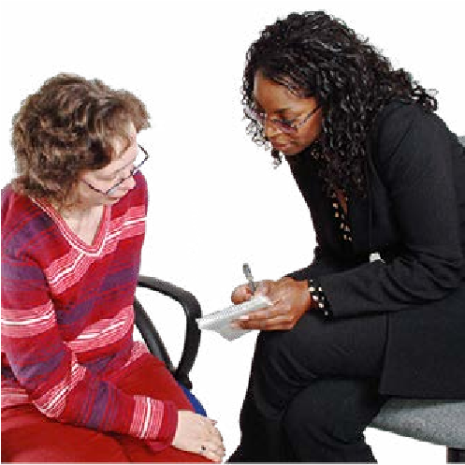

If you are worried about something you see or hear, tell the person in charge of safeguarding in your church

